Corporate Parking Permit

2022 Application Form

125 G Avenue, Gwinn, MI 49841 (906) 346-3308

Applicant Information
Name: |  |  |  |  |  |  | Permit No.
Address: |  |  |  |  |  | Phone:
City: |  |  |  | State: |  |  | ZIP:
Work Phone: |  |  |  | Best Contact Phone:
Employer: |  |  |  | Email:
Driver’s License No. |  |  |  | State:

Vehicle Information
Vehicle 1: License Plate No: |  |  |  |  |  |  |  | State:
Make: |  |  | Model: |  |  |  |  | Year:
Vehicle 2: License Plate No: |  |  |  |  |  |  |  | State:
Make: |  |  | Model: |  |  |  | Year:
Payment Method
Permit Type: (circle) |  | Corporate: $350.00
Payment Method: |  |  |  |  |  |  | Date:
Cash | Check # ____ Payable to Marquette County |  |  |  | Credit Card: https://pay.govpros.us/mi/mqtco/utility
I authorize the verification of the information provided on this form. I understand that penalties will be issued for improper parking as defined below.
Signature of Applicant: |  |  |  |  |  |  |  |  | Date:
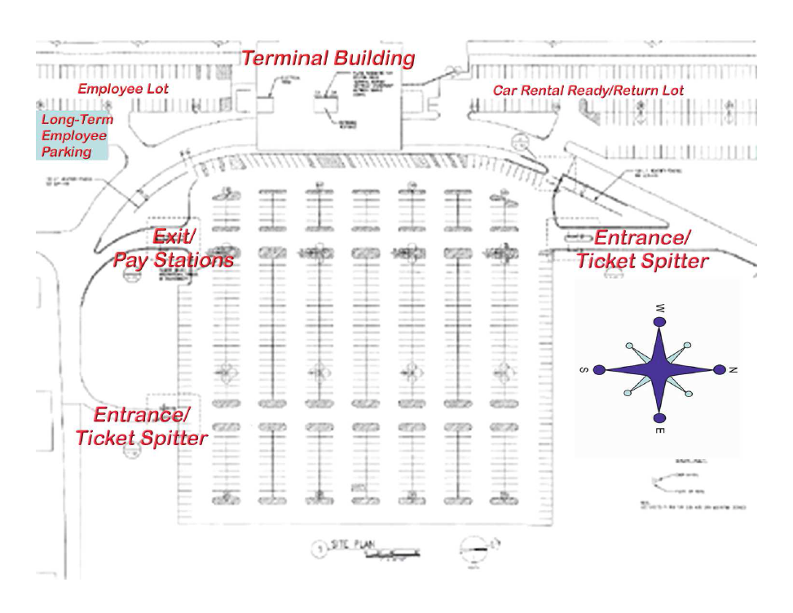
Penalties will be issued for:
- Illegally parking under the canopy at the front of the terminal, or in a space designated for handicapped use. Owners will be subject to ticketing and impound at their expense.
- Parking in front of the dumpster, or on sidewalks and/or “grassy” areas is prohibited.
- Parking in a fire lane or handicap site without the proper identification.
- If you anticipate overnight parking, or a lengthy vacation, please park in the long-term parking lot (left hand side of in the employee parking lot.
Corporate Permit Holders may park in the long-term employee parking.
Employee Parking Lot

